**URL:** <https://www.officielebekendmakingen.nl/>

In the advanced search "[Uitgebreid zoeken](https://zoek.officielebekendmakingen.nl/uitgebreidzoeken)", apply the following filters:

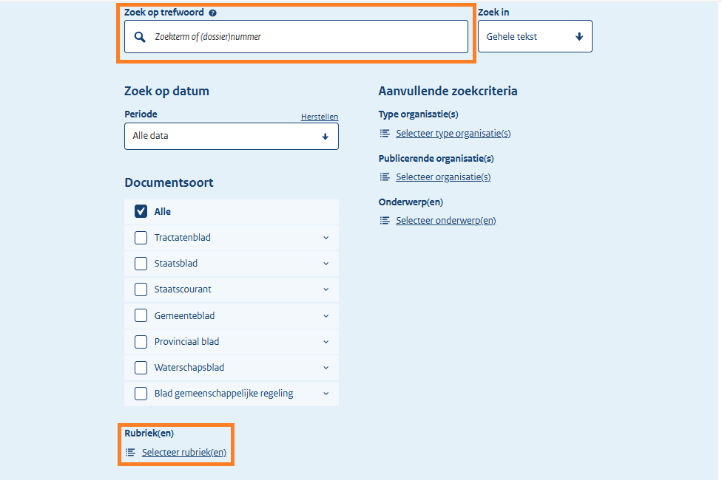We can use keyword in (A) to narrow down the search which can be found in *Netherlands - keywords for site search.xlsx* file with marked as “Yes”. It's important to remember that employing French keywords yields better results than their English counterparts. But before you enter the keywords, ensure sure the source language is set to French.

**A**

**B**

For category (B), select only Laws "Wet", Decree "Beschikking", and Small Royal Decree "Klein Koninklijk Besluit”:

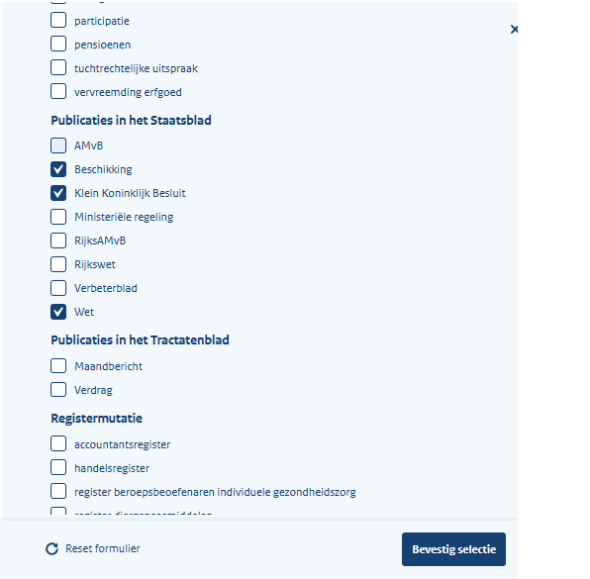

For all the results, extract the necessary metadata as below:

* Red – Original Title and Source Link
* Green – Type of Regulation
* Blue – Date of Adoption
* Purple – Entry into Force Date

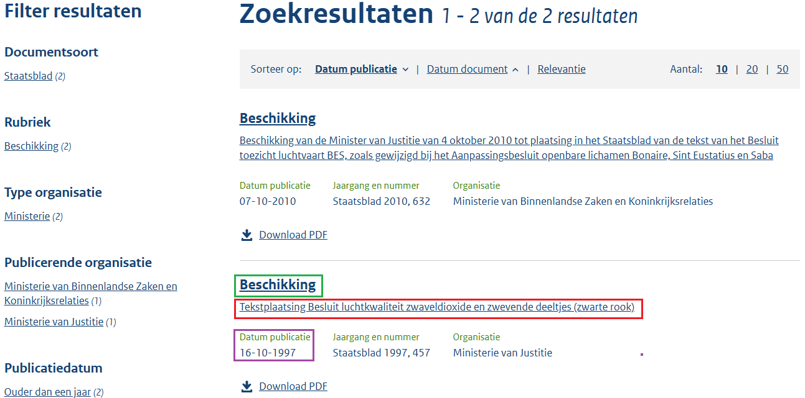

**Entry into Force Date**

**Original Title Source Link**

**Type of Regulation**

Note that we must go to the specific legislation page to find the date of adoption, which can be found by glancing at the top of the page next to the "Type of Regulation."

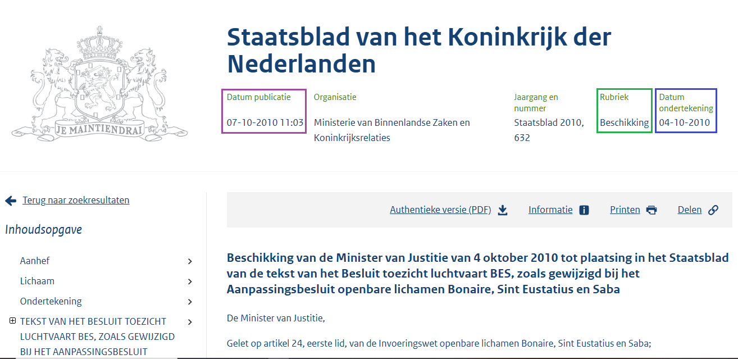

**Date of Adoption**

**Type of Regulation**

**Entry into Force Date**

The result page for several decrees clearly displays the original titles. For others, though, locating the original title necessitates visiting a particular legislation page, which is located directly beneath the date of issuance or entry into force date.

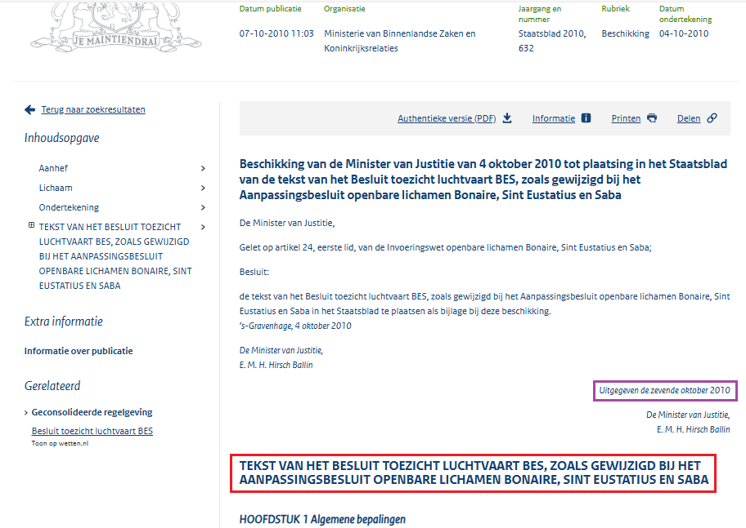

**Original Title**

Entry into Force Date

Certain laws and decrees that only have PDF versions and no web version have the required metadata displayed at the top of the page, with the exception of the original title, which appears at the bottom.

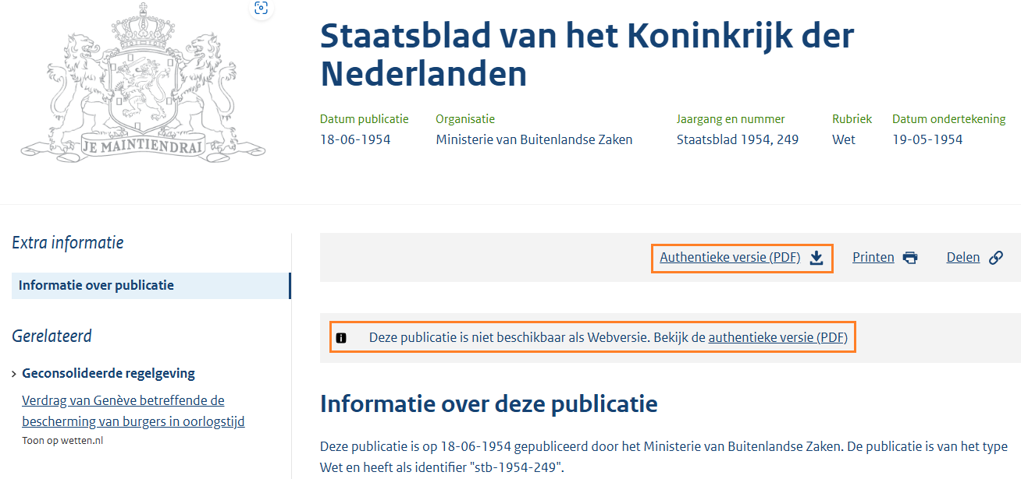

**PDF version link**

**No web version, only PDF.**

Bottom of the page:

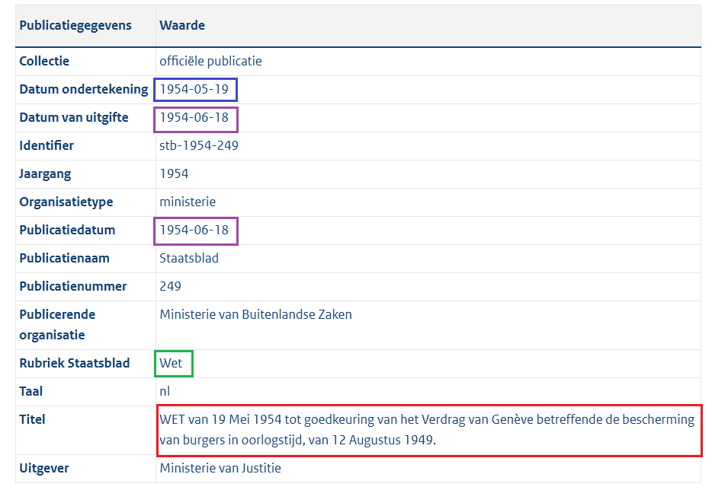

**Original Title**

**Type of Regulation**

**Date of Adoption**

**Entry into Force Date**

**Entry into Force Date**